Windows Tips

February/March 2006

I am sorry about the January edition not getting out. I was busy and forgot about it.
The Windows Tips Club (and the rest of the website) are both down. I will notify you when I can get them working.

Microsoft Word
All right, this one is a bit dull, especially for people who don’t like using the keyboard commands, but here goes:

Those special characters can get kind of annoying sometimes, going to your menu every time. So, you can use these “simple” (kind of) keystrokes:

To use these, turn Num Lock on and prepare to enter numbers. Hold down the Alt key and key in the numbers shown below. Release Alt, and the symbol jumps into your document.
Copyright: 0169
® : 0174
¼ : 0188
½ : 0189
¾ : 0190

There are plenty of other ones too. To find more, go to Start >Run and type charmap, then click OK. Click the letter or symbol you want to know the code for, then look in the lower-right corner of the window. You will see a notation that looks somewhat like this:
Where it says “Keystroke” in the right, type those numbers into your keyboard using the technique described.
Note that not every symbol has a code.

IE/Firefox
This month is a bit of an extension. All credit to Windows XP Hacks & Mods for Dummies, Second Edition. It is a faster way to get the shortcut described in last month’s tips.
Ever wanted to get to a favorite website really fast? Sure, you could put it in your Favorites or Bookmarks, but there is an even faster way. Right-click the desktop, choose New Shortcut, and type the address into the box. Click Next and type a name for your shortcut. Click Finish and put the shortcut on your desktop or Quick Launch bar. Of course, it doesn’t have to be there.

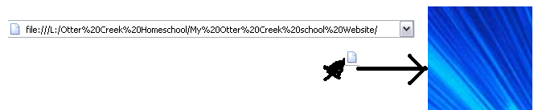
Well, even easier! See the little icon to the left of the URL? Drag it to the desktop and you have a shortcut!

That’s my mouse pointer down there. Yeah, right!
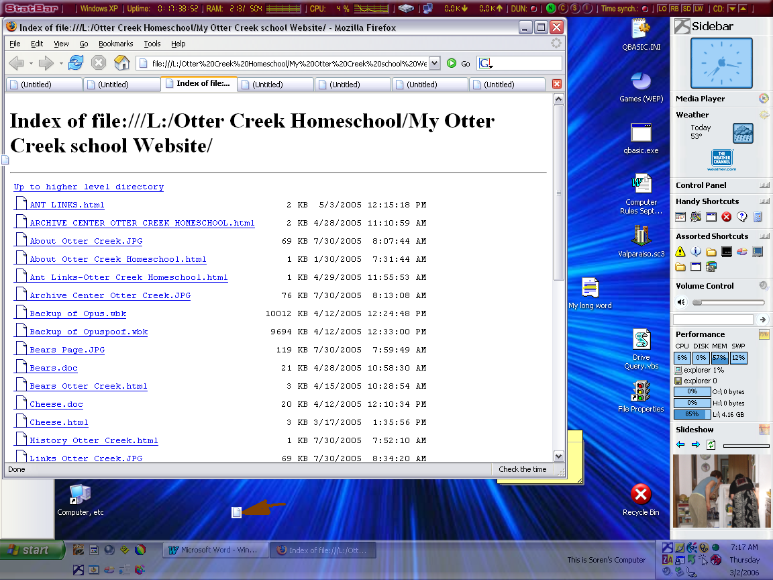
Notepad (This may be the last time Notepad appears {again})
NOTEPAD PRINTS VERY FUNNY! Okay, okay, it’s livable, but annoying. It puts the filename at the top of each page. To get rid of this nonsense, start Notepad, go to File>Page Setup, then delete the “&f” code symbol in the box. This should take care of it.

The picture is on the next page.

Windows Explorer
OK, you have a folder full of pictures and want to see a slideshow. The task pane isn’t out, and you have no idea how you are going to get a slideshow. Right-click on the first picture, choose Open With, and choose Windows Picture and Fax Viewer. Make sure the window is selected, and press F11. It is at the top of the keyboard close to the right, unless you have an archaic keyboard. If you hate using keyboard shortcuts, the button is fifth from the right and is a picture of a screen.
Bonus Tip: If you find a picture that needs to be rotated within a slideshow, press Ctrl-L or Ctrl-R. If you don’t want to use the keyboard, right-click and choose Rotate [direction].

General Windows
Keystroke-Lovers’ Tip: Alt-F4 will close any Windows program.

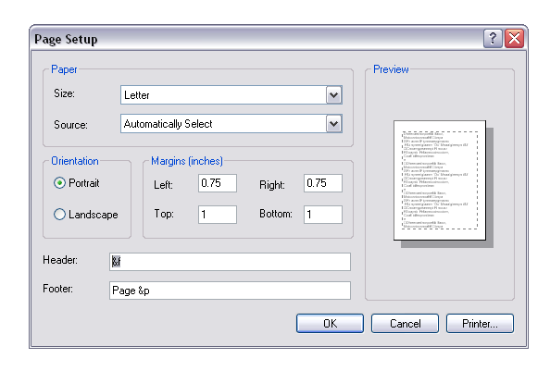

StatBar
StatBar has one big annoyance: It appears that you can’t change the order of your panels. Unfortunately, there is no way to get out of this except fooling around a bit. Write down a list of all your current panels, then right-click on StatBar and choose StatBar Configuration. Click the top entry, then press the left arrow in the middle of the two selection boxes. Do this for all of the entries. Then choose the first panel you want (it will appear on the left), and push it to the right. Do this for them all, then click Apply and verify that the panel configuration is correct by checking StatBar. It may take some trial and error to get it correct. Click OK, and unless something strange happens (it has to me) you won’t have to do this again. I would write down the order, though…

The Escape Key- One Million Uses
I think the Escape key is one of the neatest keys on the keyboard. Nobody uses it because
- it is on the keyboard and
- nobody knows about its uses

Therefore, I will tell you some uses, one a month. I don’t know nearly all of them, so look on!

Each month’s current tip will be labeled in bold.
The Escape key is often labeled Esc, and is ALWAYS in the upper-left corner of the keyboard. If your keyboard has shortcut buttons, the Escape key will be below them.

- To escape from Menuland: If your keyboard doesn’t seem to work, you may be caught in Menuland. Press Esc to leave.
- Close unwanted dialog boxes: If you accidentally open a box such as Open, just press Esc to leave.
- Stop loading a page in IE, Firefox, Mozilla, Netscape, or just about any other browser you can think of: If you accidentally click a link, just press Esc to stop it loading.

Programs to Get:
These programs will have a tip column in the future.
StatBar- What a neat program! It well show you practically everything about your computer. As an added bonus, it shows buttons to launch programs. Cleaner desktop ahead!

Desktop Sidebar – The best add-on to the taskbar and desktop ever!
It has a performance space that can be added. Prepare, though, to spend a few minutes customizing it. If you are really crazy about what is on it, you may spend several hours. (I did.)
If you are low on screen space, you can set it to auto-hide, even telling it a delay time between moving your mouse to the side and it popping out.

Email Fraud Woes
This column will replace Crazy Computers this issue.
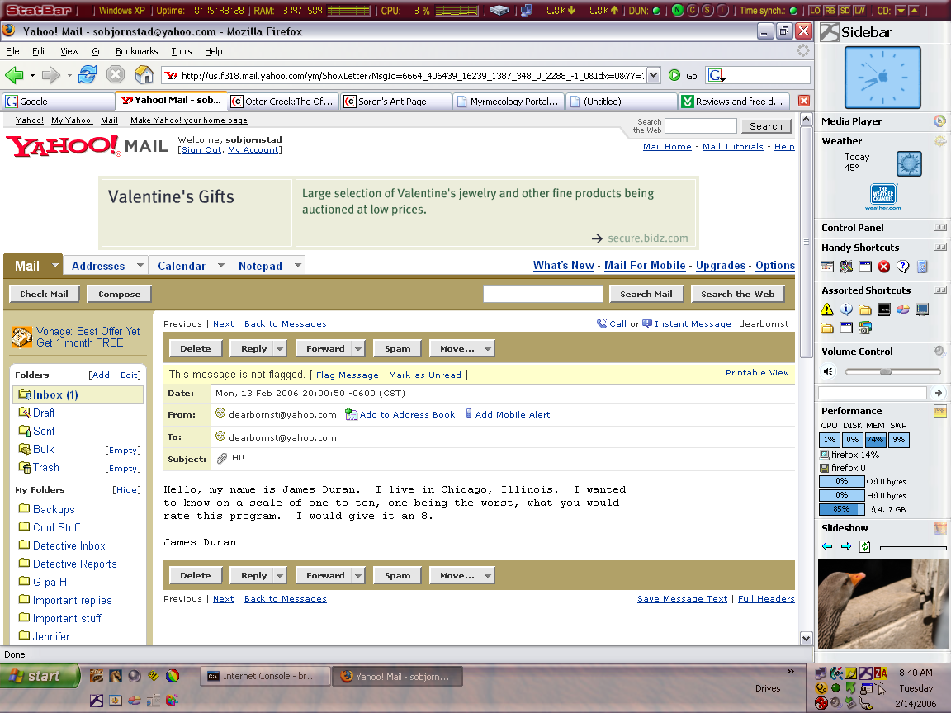

How about this message for an attachment fraud? Like I would open this attachment!

The attached PDF, How to Prevent Internet Fraud, will provide a little bit of insight on avoiding email viruses and other email fraud.

NOTICES

Windows Tips is getting to be a pretty big thing. I just don’t have the time to write a five-page newsletter every month. It will be scheduled for two months; they may come out early, but don’t bet on it.

If anyone has a tip that they would like published, let me know! Please email me at sobjornstad@hotmail.com. Feel free to email me about the newsletter and/or your tips. Your tip will also be published on the Windows Tips Club website.

Windows Tips Club is up and running. With only one member so far, there isn’t all that much there! Members receive the password to Windows Tips Club website and are able to have their tips and email addresses posted there. They also have access to the Best Tips In The Universe area, which I am not done with yet. Members also will have access to any previous Windows Tips newsletter, whether in the archive center or not, in full .doc format (or .rtf, if you prefer), directly emailed from Soren. Please do not email me at any of my “normal” addresses. Instead, please send all mail related to Windows Tips to sobjornstad@hotmail.com, my new address for Windows Tips. I will check it as soon as I can.

To get into the Windows Tips Club, one of Soren’s tips must have revolutionized your work. Send a screenshot of your workspace with the tip you are using for entrance (no larger than 800 x 600 pixels, please). To take a screenshot, refer to this month’s General Windows section. Thanks to all for their support of Windows Tips.

Please excuse the large size of Windows Tips. I am doing all I can to keep the size to a minimum, but all these high-quality (though I’m working on this too) pictures make the size shoot up fast.

