Windows Tips

February/March 2006

I am sorry about the January edition not getting out. I was busy and forgot about it.
The Windows Tips Club (and the rest of the website) are both down. I will notify you when I can get them working.

Microsoft Word
All right, this one is a bit dull, especially for people who don’t like using the keyboard commands, but here goes:

Those special characters can get kind of annoying sometimes, going to your menu every time. So, you can use these “simple” (kind of) keystrokes:

To use these, turn Num Lock on and prepare to enter numbers. Hold down the Alt key and key in the numbers shown below. Release Alt, and the symbol jumps into your document.
Copyright: 0169
® : 0174
¼ : 0188
½ : 0189
¾ : 0190

There are plenty of other ones too. To find more, go to Start >Run and type charmap, then click OK. Click the letter or symbol you want to know the code for, then look in the lower-right corner of the window. You will see a notation that looks somewhat like this:
Where it says “Keystroke” in the right, type those numbers into your keyboard using the technique described.
Note that not every symbol has a code.

IE/Firefox
This month is a bit of an extension. All credit to Windows XP Hacks & Mods for Dummies, Second Edition. It is a faster way to get the shortcut described in last month’s tips.
Ever wanted to get to a favorite website really fast? Sure, you could put it in your Favorites or Bookmarks, but there is an even faster way. Right-click the desktop, choose New Shortcut, and type the address into the box. Click Next and type a name for your shortcut. Click Finish and put the shortcut on your desktop or Quick Launch bar. Of course, it doesn’t have to be there.

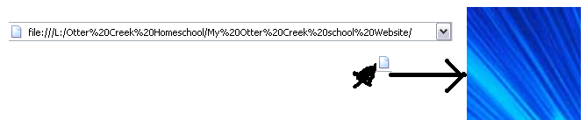
Well, even easier! See the little icon to the left of the URL? Drag it to the desktop and you have a shortcut!

That’s my mouse pointer down there. Yeah, right!
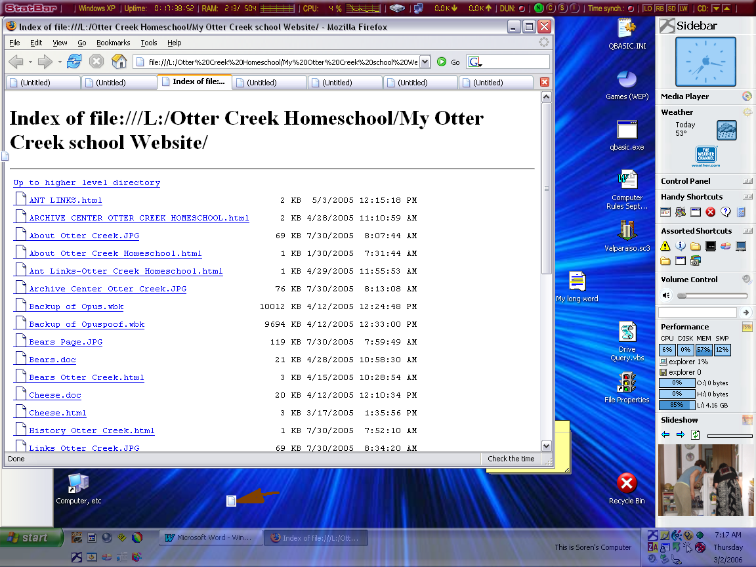
Notepad (This may be the last time Notepad appears {again})
NOTEPAD PRINTS VERY FUNNY! Okay, okay, it’s livable, but annoying. It puts the filename at the top of each page. To get rid of this nonsense, start Notepad, go to File>Page Setup, then delete the “&f” code symbol in the box. This should take care of it.

The picture is on the next page.

Windows Explorer
OK, you have a folder full of pictures and want to see a slideshow. The task pane isn’t out, and you have no idea how you are going to get a slideshow. Right-click on the first picture, choose Open With, and choose Windows Picture and Fax Viewer. Make sure the window is selected, and press F11. It is at the top of the keyboard close to the right, unless you have an archaic keyboard. If you hate using keyboard shortcuts, the button is fifth from the right and is a picture of a screen.
Bonus Tip: If you find a picture that needs to be rotated within a slideshow, press Ctrl-L or Ctrl-R. If you don’t want to use the keyboard, right-click and choose Rotate [direction].

General Windows
Keystroke-Lovers’ Tip: Alt-F4 will close any Windows program.

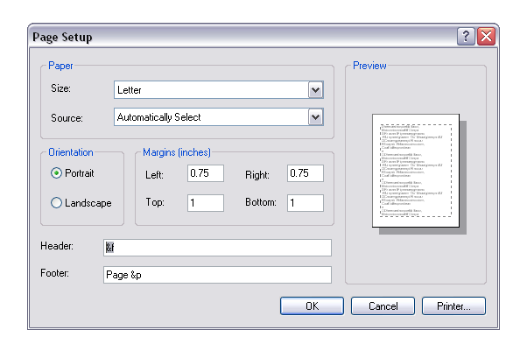

StatBar
Since StatBar has never been in here before, I am going to tell you a little bit about it.
The program can show you lots of things. I will suggest some useful panels, but you can do anything you want. Right-click anywhere on the bar and choose StatBar Configuration.

- It’s up to you to choose if you want the Win XP text at the left. It’s called Windows Version in the configuration window. It seems like there would be no point in keeping it there, but if you mouse over it, you will see more info about your version. It could be a little useful.
- If you use power-saving functions or just hate leaving your computer running too long, get the Windows Uptime module. This tells you how long your computer has been running. It’s a good idea to restart your machine if it goes over 2 days.
- GET THE LOCKS STATUS MODULE! Pretty self-explanatory, but it also shows the status of the Insert key. Hurray!
- I wouldn’t get the CD Door Eject/Close module. Although it seems useful, I almost never used it when it was there.
- Skip the Master Volume Control. You can get a much easier one on Desktop Sidebar.
- If you use dial-up internet, get both the Dial-up Networking Status and the Network Traffic Meter. If you use cable or DSL, get just the NTM, if you want to take charge of your connection, that is, and keep the computer from hiding the details.
- Get the CPU Usage, even though Desktop Sidebar has a good one, because it has a history graph, something DSidebar doesn’t have.
- If you are looking for something to fill more space at the end of your panel-adding frensy, then get the RAM Usage module.
- I would recommend the Time synchronization module unless you have absolutely no space. It lets you change the time intervals better, and you can manually synchronize by double-clicking.
- I would take the Quick Launch. Setting it up is a little strange, but if you don’t try to browse for a folder, it should work just fine. To add something, go to the File Paths button on the left.
- If your primary email address goes to a desktop email program such as Outlook or Thunderbird, the Email Launcher would be worth it. It creates a new, blank message.
- Get the Disk Info. It takes about 20 pixels, and clicking it tells you all about your drives and also how much your machine and all removable drives are together able to store and how much has been used.

Once you have added these, you should flip a few config switches.
- Under Module Selection, choose Remember this selection when screen resolution changes. Can’t live without it.
- Under General Options, uncheck Open Website on logo double-click. I have been transported to their site accidentally many times.
- If you use XP, you may want to make it slightly transparent. If you decide on it, choose 15%. It’s worked well for me.
- Networking just lets you choose a time server. Borrrrrring.
- Enjoy StatBar!
The Escape Key- One Million Uses
I think the Escape key is one of the neatest keys on the keyboard. Nobody uses it because
- it is on the keyboard and
- nobody knows about its uses

Therefore, I will tell you some uses, one a month. I don’t know nearly all of them, so look on!

Each month’s current tip will be labeled in bold.
The Escape key is often labeled Esc, and is ALWAYS in the upper-left corner of the keyboard. If your keyboard has shortcut buttons, the Escape key will be below them.

- To escape from Menuland: If your keyboard doesn’t seem to work, you may be caught in Menuland. Press Esc to leave.
- Close unwanted dialog boxes: If you accidentally open a box such as Open, just press Esc to leave.

Programs to Get:
These programs will have a tip column in the future.
StatBar- What a neat program! It well show you practically everything about your computer. As an added bonus, it shows buttons to launch programs. Cleaner desktop ahead!

Desktop Sidebar – The best add-on to the taskbar and desktop ever!
It has a performance space that can be added. Prepare, though, to spend a few minutes customizing it. If you are really crazy about what is on it, you may spend several hours. (I did.)
If you are low on screen space, you can set it to auto-hide, even telling it a delay time between moving your mouse to the side and it popping out.

Email Fraud Woes
This column will replace Crazy Computers this issue.
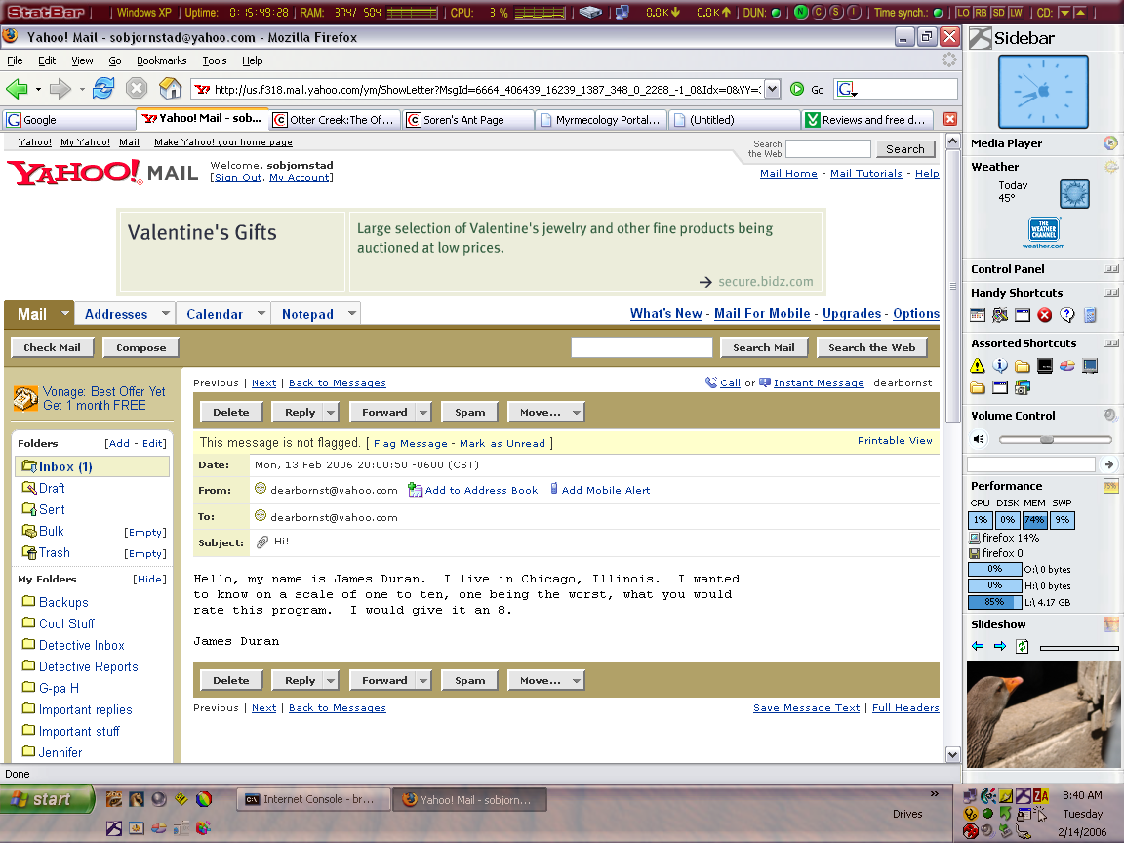

How about this message for an attachment fraud? Like I would open this attachment!

The attached PDF, How to Prevent Internet Fraud, will provide a little bit of insight on avoiding email viruses and other email fraud.

NOTICES

Windows Tips is getting to be a pretty big thing. I just don’t have the time to write a five-page newsletter every month. It will be scheduled for two months; they may come out early, but don’t bet on it.

If anyone has a tip that they would like published, let me know! My address is sobjornstad@yahoo.com. Feel free to email me about the newsletter and/or your tips.

Please excuse the large size of Windows Tips. I am doing all I can to keep the size to a minimum, but all these high-quality (though I’m working on this too) pictures make the size shoot up fast.

Many people have probably missed the so-called “attached” file on the Indexing Service last issue. It is in this series of attachments.

