Windows Tips October 2005

Five Ways To Delete A File [September, October] (Until November 2005)
- Click the X button on the toolbar.
- Click File>Delete.
(Old:)
- Press the ‘delete’ key.
- Right-click, choose ‘delete’.

Windows Explorer

Press (Windows key) + E to start.

Internet Explorer
Sorry, no more tips here till you switch to Firefox.

Firefox
Do you know how those browser windows always pile up? Have you ever wanted more than one home page? Probably the answer is yes. Well, now you can have lots of pages in one window and even have as many home pages as you want.
To get started, press the keystroke Ctrl + T. A new bar will appear along the top. This is called the Tab bar. You can switch between any pages you have open by clicking on the tab of that page. You can open a new tab anytime by right-clicking on the Tab bar and clicking New Tab.
To make a multiple-tab home page, open all the pages you want in tabs, then go to Tools>Options. On the left there will be five tabs. Make sure you are on the General tab, then click the Use Current Pages button. Click OK and close the browser.

Don’t have Firefox? Download it now at:
http://download.mozilla.org/?product=firefox-1.0.7&os=win&lang=en-US
Your download will start automatically after confirmation.

Microsoft Word
Press Ctrl + Shift + L to start a bullet list.

Notepad (One Time)
Want a journal that automatically inserts the time and date for you? Here it is. Go to Start>Run and type ‘notepad’. Type ‘.LOG’ on the top line (case sensitive) and close the file. Tell it to save it when it asks. Open it again and it will insert the time and date at the bottom of the document.

Crazy Computers (by Soren Bjornstad)
Not so long ago, I got a message like this one:
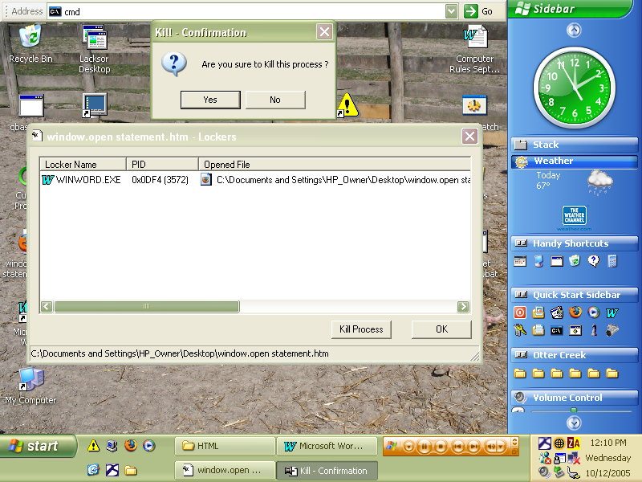
What exactly does it mean, “Are you sure to kill the process?” Well, it certainly doesn’t mean what it is supposed to mean. Too many programs now don’t have proper text, and this one sure comes in that class. There are bound to be more with the same sort of thing, and some of those will undoubtedly, and unfortunately, have worse results. Eventually, some of these will probably get fixed eventually, but in the meanwhile, we will probably just have to deal with crazy boxes.

If you have any crazy computer things, take a screenshot by pressing the Print Screen button (sometimes labeled PrtScn or Print Scr) and send it to:
sobjornstad
@yahoo
.com.
(Split-line to prevent worms from getting the address)

